Roll No. :2503a52531
Name: B.Poojitha
Batch: 18
Question 1: Zero-Shot Prompting (Palindrome Number Program)
Write a zero-shot prompt (without providing any examples) to
generate a Python function that checks whether a given number is a
palindrome.
Task:
• Record the AI-generated code.
• Test the code with multiple inputs.
• Identify any logical errors or missing edge-case handling.

Prompt:
Create a python function to check weather a given number is a palindrome and test with user inputs.
Code:
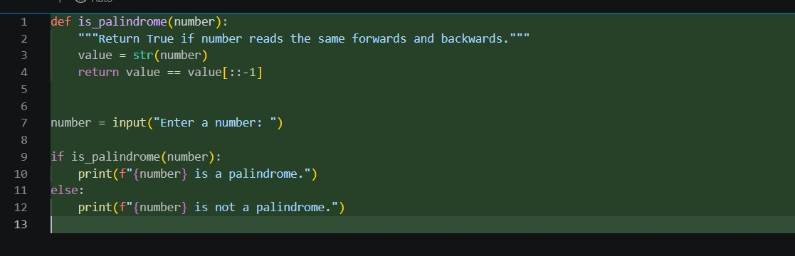
Output:
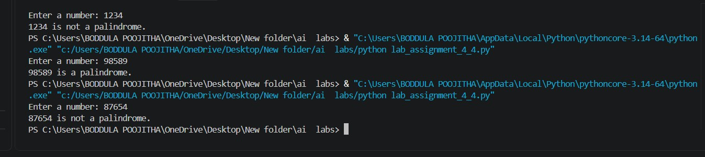
Observation:
- The zero-shot prompt generated a Python function to check whether a number is a palindrome.
- The generated code was simple and easy to understand.
- The program was tested with multiple inputs.
- It correctly identified palindrome and non-palindrome numbers.
- Single-digit numbers were also handled correctly.

